Sneaker Store

SE452 – Object Oriented Enterprise Application Development

Greatest Chicago sneaker store

Contents

Overview 2

Requirements 2

Use Case 2

Description of problem 2

Design 3

Sequence of major functionality 3

Web UI (Common case) 3

Table layout 3

Deployment 3

Discussion of how your design met the requirements 3

Discussion of lessons learned 4

Decision Log 5

Milestone Screenshot 6

# Overview

Greatest Chicago sneaker online shop that lets the user:

* Register for a sneaker raffle
* Add sneakers to shopping cart
* Look up sneaker stores by zip code

# Requirements

## Use Case

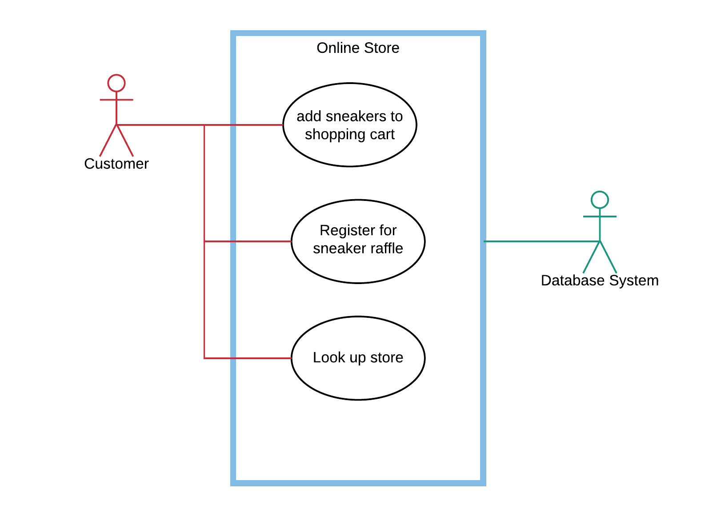

## Description of problem

Sneaker online store that supports human interaction using Web. Users can Register for a sneaker raffle, add sneakers to shopping cart, look up sneakers store by zip code.

# Design

## Sequence of major functionality

### Web UI (Common case)



## Table layout



There is only one table to fulfill the requirement for persistence.

## Deployment

All the classes were packaged into one deployment unit to keep things simple.



Queue: CalculatorQ

Data source: jdbc/sample

# Discussion of how your design met the requirements

This sample project did not meet the functional requirements but was created to validate the component interaction for different technology pieces.

This also serves as a reference document for other projects of basic expectation of the course project work

# Discussion of lessons learned

# Decision Log

|  |  |  |  |
| --- | --- | --- | --- |
| **Problem** | **What was decided** | **Alternatives considered** | **Rationale** |
| Which IDE to use | IntelliJ | Eclipse | IntelliJ had all the components integrated in one UI |
| Database | PostgreSQL | MySQL | Open source and I’ve worked with PostgreSQL |
| Code repo | GitHub | Local Machine | I would be able to have access to the code in any computer |

# Milestone Screenshot

